Deviated-tetra Test Deviated wellpath in tetra model

Type: Post
Tested functionality: Deviated Wellpath (snaking well)
Model, mesh GoCad/Tetra
Formation: linear
Result: Optimum mudweight
Class: GUI/mechanical
Since GEOMEC version: 3.2

Test description (more detailed)
Automatic selection of points along wellpath
Visualisation of the wellpath linegraph.
Checking snaking up of the well in the graph

Figure model:
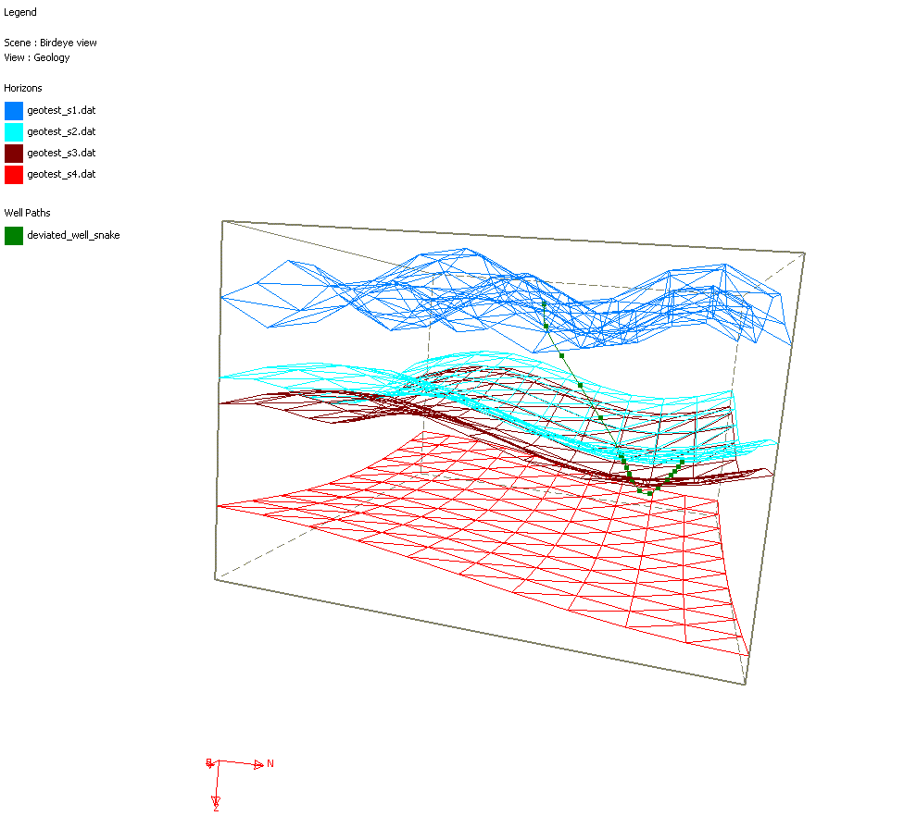

Directories for input and output files:
sourcesafe path: Test/Post/Wellpath/Dstabor ccoupling/deviated-tetra

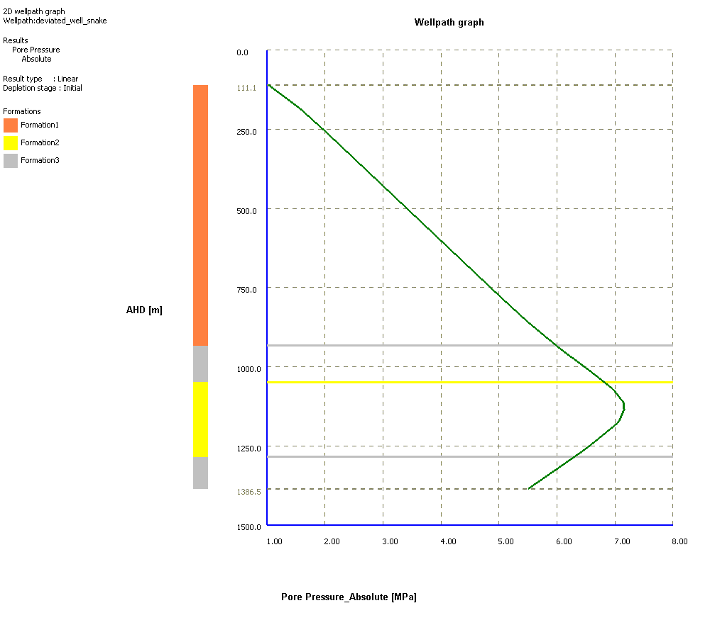

Results

AHD [m] | Pore Pressure_Absolute [MPa]
111.13 | 1.03
111.18 | 1.03
185.88 | 1.58
260.69 | 2.03
316.84 | 2.35
335.49 | 2.46
410.30 | 2.89
485.10 | 3.32
522.50 | 3.54
559.91 | 3.76
634.71 | 4.19
709.52 | 4.62
728.17 | 4.73
784.32 | 5.05
859.13 | 5.50
933.83 | 5.99
934.03 | 5.99
944.42 | 6.06
954.90 | 6.14
962.81 | 6.20
965.38 | 6.21
975.87 | 6.29
986.35 | 6.37
991.59 | 6.41
996.83 | 6.45
1007.32 | 6.52
1017.80 | 6.60
1020.37 | 6.62
1028.29 | 6.67
1038.77 | 6.74
1049.15 | 6.81
1049.15 | 6.81
1049.35 | 6.82
1070.64 | 6.96
1092.04 | 7.06
1108.13 | 7.12
1113.43 | 7.15
1134.82 | 7.16
1156.21 | 7.11
1166.91 | 7.08
1177.60 | 7.05
1199.00 | 6.90
1220.39 | 6.76
1225.69 | 6.73
1241.78 | 6.62
1263.17 | 6.47
1284.46 | 6.30
1284.46 | 6.30
1284.66 | 6.30
1310.11 | 6.10
1335.55 | 5.90
1360.99 | 5.70
1386.43 | 5.50
1386.53 | 5.50

